MAE 3724, Systems Analysis and Introduction to Controls

PreLab for MATLAB Lab 2 – Plotting, TF, Step, iLaplace and ode45

To submit this work, you will be uploading a modified version of this MS Word file to Canvas.

1. **Download and run the following four files from our Canvas course page:**
   1. SimplePlotting.m
   2. tf_demo.m
   3. InverseLaplace.m
   4. SecondOrderODE.m

**Bring those four files with you on your computer when you come to lab. During the lab, you will be modifying these files to solve other problems.**

1. **Modify SimplePlotting.m to do the following:**
   1. Plot  from x=0 to x=6 pi, using 500 points, titles and labels
   2. Plot  from x=0 to x=6 pi, using 500 points, titles and labels
   3. Plot both on the same graph, using titles, labels and a legend

*%% Part2*

x=linspace(0,6*pi(),500);

y1 = exp(-x).*(sin(x)).^2;

y2 = exp(-x).*(cos(x)).^2;

plot(x, y1);

title('exp(-x)sin(x)^2');

xlabel('X Value');

ylabel('Y value');

*pause*

plot(x,y2);

title('exp(-x)cos(x)^2');

xlabel('X Value');

ylabel('Y value');

*pause*

plot(x,y1,'r',x,y2,'g');

title('Graph Comparison');

xlabel('X Value');

ylabel('Y value');

legend('exp(-x)sin(x)^2','exp(-x)cos(x)^2');

*pause*

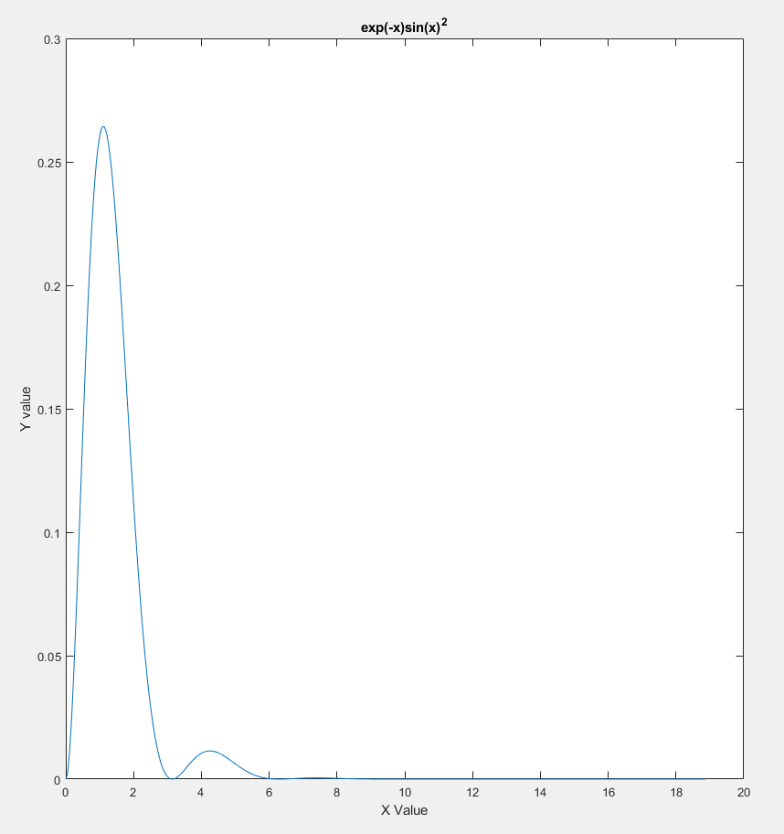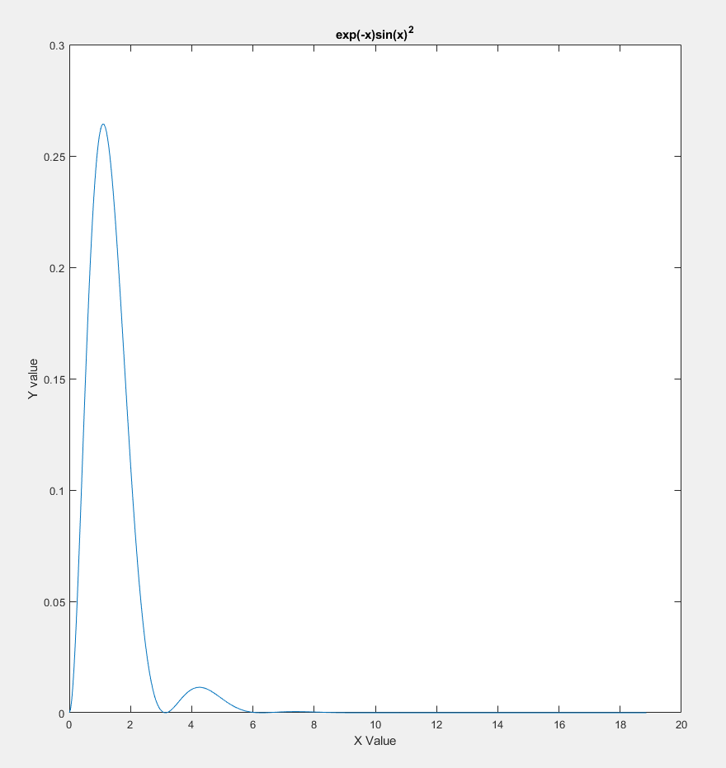

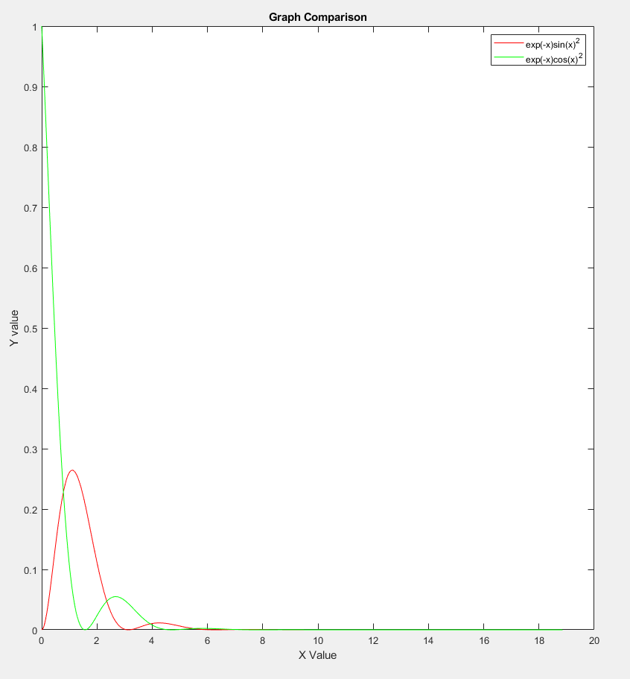

1. **Modify tf_demo.m to do the following:**
   1. Use the tf() function to define a system variable for: 

Use the step() function to plot the response of the system for  (a unit step).

*%% Part 3*

num = [1];

den = [1,4,6,8];

T = tf(num,den)

step(T);

title('Step Response');

xlabel('Time - ');

ylabel('Amplitude');

*pause*

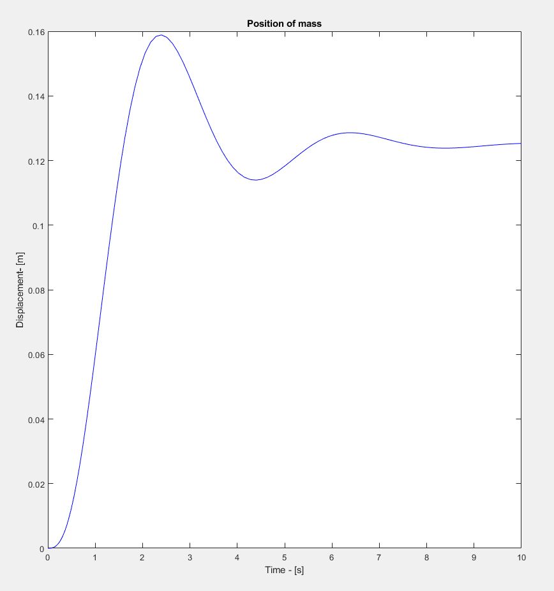

1. **Modify InverseLaplace.m to do the following:**
   1. Use ilaplace to determine the inverse laplace transform for: 

*%% Part 4*

syms s;

F = (2*s+1)/(3*s^3+4*s^2+20*s);

ilaplace(F)



1. **Modify – SecondOrder ODE.m to do the following:**
   1. Use the ode45() function to plot the solution for:  where  
        (a unit step) over the range 0 to 10 seconds. All initial conditions are zero.

Plot the position and velocity on separate graphs

*%% Part 5*

[t,y1] = ode45(@deriv,[0,10],[0,0,0]);

plot(t,y1(:,1),'b');

title('Position of mass');

xlabel('Time - [s]');

ylabel('Displacement- [m]');

*pause*

plot(t,y1(:,2),'r');

title('Velocity of mass');

xlabel('Time - [s]');

ylabel('Velocity - [m/s]');

*pause*

*%% Function Definitions*

function XDOT = deriv(t,X)

*% System Parameters*

*% Rename states*

    x = X(1); xd = X(2); xdd = X(3);

*% Initiate forcing function*

    f = 1;

*% write the non-trivial equations using nice names*

    xddd = f - 4*xdd - 6*xd - 8*x;

    XDOT = [ xd; xdd; xddd] ;  *%return the derivative values*

*end*

.

